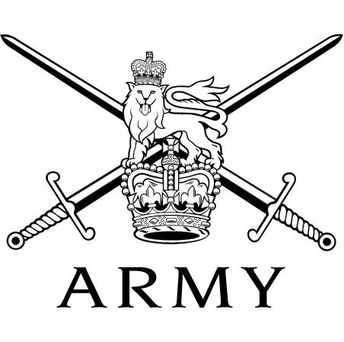 | HEADQUARTERS ROYAL SIGNALS  Blandford Camp, Blandford Forum, Dorset DT11 8RH  Telephone: (01258) 482014  Military Network: (94371) 2014  Facsimilie: (01258) 482084  E-Mail: steven.lockwood745@mod.gov.uk  tracey.muers101@mod.gov.uk | 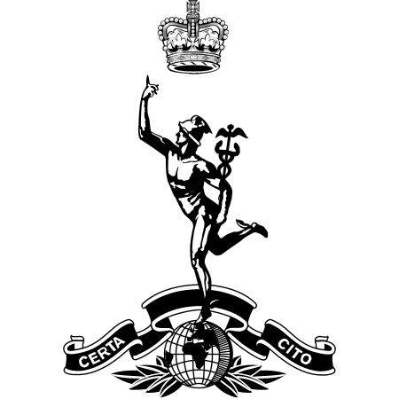

See Distribution | Reference: | RSIGNALS 4.5.2
See Distribution | Date: | 2 May 2023

ROYAL SIGNALS CORPS WEEKEND – BLANDFORD CAMP 16 – 17 JUNE 2023

1. Introduction. By kind permission of the Blandford Garrison Commander, the Corps Weekend will take place at Blandford Camp over the period 16 - 17 June 23. This weekend will enable the Regular, Reserve and Retired community to have an enjoyable and entertaining time with plenty of opportunities to catch-up with old friends and celebrate good times together.

2. Programme of Events. An outline Programme of Events is as follows:

a. 16 Jun 23 1230hrs – 1700hrs Reception open at the entrance to camp off Black Lane.

1500 – 1800hrs Welcome drinks – Colins Bar, Blandford Forum
Tpt from the Guardroom 1430hrs onwards.

1830hrs – 2359hrs All Ranks Meet & Greet with Curry Supper in the Officers’ Mess.

b. 17 Jun 23 0800hrs – 1000hrs Reception open at the front gate to camp off Black Lane.

1000hrs – 1045hrs Standard Bearers Competition – Hawke Square

1100hrs Princess Royal Parade on Hawke Square (to include a march past of veterans).

1130hrs – 1600hrs Museum open (free for RSA members & guests).

1230hrs – 1800hrs Royal Signals displays, food, drinks and entertainment on Elizabeth Field.

1800 – 1900hrs Sunset Ceremony – Hawke Square

1900hrs – 2359hrs Evening Function – Officers Mess .

c. 18 Jun 23 1200hrs All Accn handed back

3. Camp Access. Entry into Blandford Camp will be Via the Main Gate at the top of Black Lane.

4. Security. Car passes will be issued on arrival and must be prominently displayed in the vehicle whilst on Camp with your mobile telephone number written on the pass. They should be returned to the box on the right-hand side of the road upon exit. Those attending must be aware that an increased security state may affect the event. It is, therefore, important that a contact telephone and/or e-mail is provided on the application to attend and be clearly displayed on your car pass.

5. Arrival. On entry, all those attending should have with them their Veterans card, RSA membership card, current driving licence or passport.

6. Accommodation. If you have booked accommodation, you will be directed to this on your arrival. Members who have booked to bring their own tents, caravans or mobile homes, will be housed on the campsite area near the pavilion and running track.

Confirmation of your booking into accommodation will be communicated to you by the RSA AO in the form of an email. If you do not receive an email from her then you are not booked into this accommodation.

There are no chemical waste facilities on site for caravans/mobile homes; however, the fixed infrastructure facilities can be utilised. Unfortunately, there is no power hook ups available.

Caravans / tents / mobile homes will not be admitted to camp before 1200hrs on Friday 16 June.

All accommodation MUST be vacated promptly and by no later than 1100hrs on Sunday 18 June.

MEALS

7. General. Meals are available from several places on camp (at individual cost), including, the Rendezvous Café in the Glass House (Friday until 1630hrs, Saturday 0800 – 1400hrs and Sunday 0800 – 1100hrs), the Comms Café in the Museum during museum opening hours, the Soldiers’ Restaurant and food outlets on the Elizabeth Field arena.

8. 3R’s Meet & Greet, Curry Supper – Friday 16 June. By kind permission of the Garrison Commander, all ranks and members of the association and their guests are invited to the Officers’ Mess on Friday for a meet and greet. When visiting the Mess, association members are reminded of the dress code, a pre-requisite of entry, which is applicable to everyone while in the Mess, and is Shirt or Polo Shirt, Biker Cuts, trouser, trouser suit or summer dress, ties are optional.

9. 3R’s Evening Function – Saturday 17 June. By kind permission of the Garrison Command, all ranks and members of the association and their guests are invited to the Officers’ Mess on Saturday evening. When visiting the Mess, association members are reminded of the dress code, a pre-requisite of entry, which is applicable to everyone while in the Mess and is Shirt or Polo Shirt, Biker Cuts, trouser, trouser suit or summer dress, ties are optional.

10. Transport. A Minibus service around the site will be provided all weekend. The bus stops will be clearly signed along the route between the camp site and Hawk Square and in the Corps Weekend Programme. The driver will be able to be contacted by mobile phone this year and his mobile number will be made available on the day.

11. Parking. Parking for all visitors will be allocated on arrival. Disabled parking is available for Blue Badge Holders, who bring their badge, in designated areas only.

12. Corps Museum. The Corps Museum will be open as follows: Saturday 1130 - 1600hrs and Sunday 0900-1200 hrs there will be free entry to association members, on production of their RSA lapel pin. When entering with family members, a donation to the Royal Signals Charity would be appreciated. Outside these times normal charges will apply. The Museum Shop will also be open for the sale of blazer badges, cap badges, ties, brooches, plaques and a wide variety of Corps items. The Museum Café will also be open during these times.

PRINCESS ROYAL DAY PARADE

13. The RSA members will form up on the slip road next to the Harrogate Building at 1200hrs and will join the parade on the final march past.

14. Weather. All those attending are advised to bring suitable protection from the weather, be it either inclement or extremely hot.

15. Donation to the Royal Signals Charity. We are trying to reduce the financial impact on those people attending the weekend by making food at both evening functions free to those attending. As such it would be really appreciated if those attending could make a small contribution to the Royal Signals Charity during their visit. The Corps Charity Marquee on Elizabeth Field will have a ‘Tap and Go’ machine for those who would like to donate but do not carry cash.

16. All enquiries regarding the event should be made to 01258-482014 / 482290 or e-mail: steven.lockwood745@mod.gov.uk / tracey.muers101@mod.gov.uk.

Original Signed

S M LOCKWOOD
Lieutenant Colonel (Retired)
Assistant Corps Secretary

Distribution:

Area Representatives
Secretaries of Branches and Affiliated Associations
Individual RSA members upon request (via website).

There is a dress code for this event please see paragraph 8 a & b

