26 Jul 22

RSA Membership

RSA ROAD TRIP – TAKEAWAYS AND BEST PRACTICE

1. During the week 18 – 22 Jul 22 the RSA Team from Corps HQ (Gen Sec, Asst Gen Sec and the AO) conducted a UK wide Road Trip. The aim of the week was to re-engage with as many Association members as we were able to following the substantial restrictions imposed by 2 years of living with COVID. The trip was considered a great success and the feedback from all locations was very positive. The roadshow visited the following areas:

a. Liverpool - 34 people in attendance from the NW of England, Edinburgh – 16 people in attendance from Scotland, Catterick – 15 people in attendance from the NE of England, Rotherham – 12 people in attendance from the East Midlands and South Yorkshire, Shrewsbury – 17 people in attendance from the West Midlands and Shropshire, London – 11 people in attendance from East Anglia, the Home Counties and Central London and Salisbury – 9 people in attendance from the SW of England.

b. On the Friday morning we conducted a virtual meeting where we had around 25 people in attendance who were unable to attend the face-to-face meetings.

2. It must be highlighted at this point that the Road Trip was conducted during some of the hottest temperatures ever seen within the UK and that many members were either away on holiday or suffering after the UK’s third biggest COVID infection period.

3. There were a number of takeaways from the week as well as ‘Best Practices’ which are listed below:

a. There was a request from our veterans to look at opportunities for closer engagement with the Master, either face to face (Q&A, etc) or virtually (AGM, etc). Whilst this is a fantastic aspiration, it will, of course, become even more difficult to arrange when the Master is DCGS!

b. Corps weekend was not really an option for those in the north, even if we laid on more accommodation. The cost of travelling, etc, becomes prohibitive. We should acknowledge this and aim to run more area events; led by the area branches but supported by us. Wherever possible, these events should be open to the whole Corps family (serving and retired).

c. We need to start notifying branches of our Service leavers when we know where they will be settling. Clearly, this was already an aspiration but cannot start until we have an AA in place (hopefully in early Oct 22).

d. It was interesting to note the reduced attendance in Branches this year due to the impact of COVID (both people not engaging generally but also their focus being to get away on holiday). This could also be a factor in the RSA attendance at our centralised events. We will need to monitor this next year to see if historic levels of attendance return.

e. The template for regional events should be based on Project NOEL (i.e. local RSA reps organising, a local hotel engaged to agree a preferential rate to allow an affordable over-night event, etc).

f. We need to confirm that expenses are available for our Standard Bearers to attend events as there was confusion at the Corps Weekend. This would certainly apply to Corps Weekend and the NMA but perhaps less so for regional events, which are more discretionary.

g. There appeared to be awareness and support for the Armed Forces Breakfast Clubs. Perhaps this is a model for our RSAs to take on (i.e. multi RSA branch meets and even multi cap-badge events)?

h. Equally, we perhaps need to look at combined cap-badge events to maintain Branch activities in those areas where Branch numbers are dwindling. As I mentioned last week, we work with other cap-badges in our Regts so why should we shy away from socialising with them where it is appropriate to do so?

i. We need to start publishing everything we can to our website (Benevolence info (supporting organisations and the process for getting help); CCM and AGM minutes; Corps forecast of events; etc). The more information on there, then more it will be used.

j. There is a need to engage with the RFCAs (probably through the Corps Col / Corps Col Reserves) to make sure that facilities charges are reasonable to allow Associations to utilise their facilities.

k. Some of our best supported Branches are those who have linked into their local Reserve Unit for help and assistance. Many of their members come from the said Reserve Unit and they invite each other to events. This is a tried and tested model which, where geography allows, other Branches who are struggling for members might want to adopt?

l. There is a willingness from the Reserve and Regular units in the Corps to help RSA members with their IT Skills to allow them to gain access to the Royal Signals Website and send emails. Branches who would like to exploit this should first contact the AO (Tracey Muers) so she can open of communications with local Reserve or Regular Units.

m. Some Branches have business cards they give out to members on arrival, so they know who the key players are. These are funded by branches. An example is below:

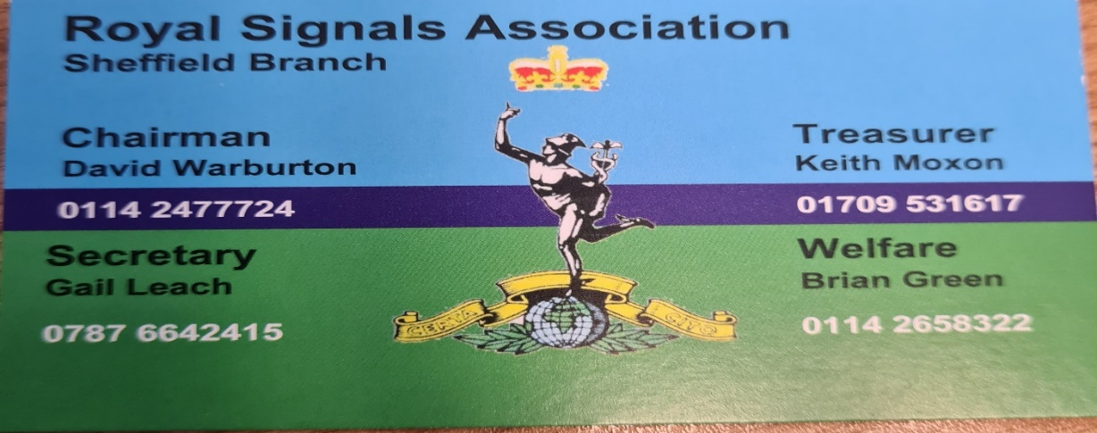

n. Bill White organised a retired QM’s convention that took place in York this year and was a great success. Next year’s event will be held at https://www.thebridgewetherby.co.uk/spa on Wed 17 May 23. If you need additional information, please contact Bill on white1947@btinternet.com.

o. After the success of the virtual meeting between Corps HQ’s and RSA members who were unable to attend the local road shows it was suggested that we should run a quarterly virtual meeting open to all members. Is there an appetite for this amongst members?

4. The points raised in this paper will be an agenda topic for discussion at the next CCM in London on Thu 13 Oct 22.

David A Craft

General Secretary
Royal Signals Association

